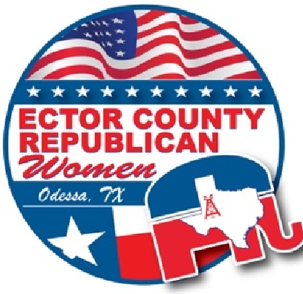
President’s Note by Debi Hays
August 12, 2025
es

Volume 25
, Issue 3

TFRW
Region #9, District #31

Ector County Republican Women
ECRW NEWSLETTER

2025 Elected Officers
President Debi Hays
VP Programs Ashleigh Amonett
VP Membership Heather Grimes
Secretary Betsy Rhodes
Treasurer Jill Miller
Past President Donna Kelm
Board Members
Legislation Judy Calloway
Campaign Activities Kathy Wise
Parliamentarian Laurie Johnson
VIP Liaison Traci Gregston
Media Paula Williams
Corresponding Secretary Diann McKee
Standing Committee Chairs
Awards. Brenda Norman
Badges. Susan Jones
Caring for America Lori Crutcher
Decorating. Sonya & Danora
Hospitality. Melanie Lively
Scholarship. Tammy Hawkins
Newsletter Donna Kelm
Website Donna Kelm
TFRW VP Programs - Sherry Hurt
TFRW District Director -Judy Calloway
TFRW Deputy President Reg 9- Debi Hayes


Summer was FUN with ECRW 2nd Patron event, Freedom and Floaties hosted by Bill Nyborg. Rachel Minor, Patron Chairman, and her co-chairs put together an evening full of laughter, great food, fantastic company, and sunshine.

The upcoming Fall Patron Event promises just as much excitement and camaraderie. I encourage you to keep an eye out for the Save the Date email blast, which will be arriving soon.
As summer winds down and election time is around the corner, I’m encouraging all members to reignite your civil engagement and prepare for the upcoming election season. It’s important to stay politically informed and active in local, state, and federal issues. ECRW prides itself on educating, inspiring, and gearing up for election time.

To kick off the fall calendar, ECRW's August 21, 2025, luncheon will feature State Representative Brooks Landgraf, with fingers crossed for a surprise speaker. The two lawmakers will provide updates on the 89th Legislative Session and Abbott’s Special Session, offering insights into key policy developments affecting Texas.

The August luncheon promises to be both informative and energizing, aligning with ECRW’s mission to empower Republicans and foster community involvement. Members and guests are encouraged to attend and take advantage of the opportunity to connect with your elected officials and fellow conservatives. Can’t wait to see everybody and catch up.

For more details or to RSVP, visit the ECRW official website.

Let’s Rally Members for the Upcoming Luncheon and Election Season

INSIDE

Speakers 2 Legislation 3
Campaign Activities 4
Membership 5
Newsletter 6
Awards 7
Governor Abbott 8
Patron Event 9-11
TFRW / NFRW Conventions 12
Election Date 13
ECRP Pancake Feed 14
Structure of Federation 15
Local Elected Positions 2026 16
Ballot For Nov. Election 17
Precinct Chair 19
Rep. Brooks Landgraf 20
TFRW Woman of Distinction 22

Vice-President Programs Ashleigh Amonett


Exciting Programs Ahead for ECRW Members!
Dear Fellow Republican Women,
I hope this message finds you well and as excited as I am about the incredible lineup of speakers we have coming to our Ector County Republican Women's Club meetings over the next few months!

This Month's Featured Speaker
Please mark your calendars and plan to join us this month for what promises to be an informative and timely presentation. We are privileged to welcome Representative Brooks Landgraf who will be providing us with a comprehensive Legislative Update. As we navigate the current political landscape, Representative Landgraf's insights into recent legislative developments and upcoming priorities will be invaluable for all of us who are committed to staying informed and engaged in the political process.
And here's something to add a little extra excitement to the luncheon—we may have a surprise guest joining us! I can't reveal all the details just yet, but I promise it will be worth your time to attend.

Looking Ahead to September
I'm currently working behind the scenes to coordinate what I believe will be an extra special September meeting. While I'm still finalizing all the details and confirmations, I can assure you that this event will be something truly memorable for our club. Stay tuned for more information—I'll be sharing all the exciting details with you as soon as everything is confirmed!

October Speaker Announcement
Mark your calendars now for October, when we'll have the honor of hosting Randolph Brooks as our guest speaker. Mr. Brooks brings a wealth of experience and perspective that I know our members will find both engaging and enlightening.

Your Attendance Makes the Difference
These exceptional speakers are taking time from their busy schedules to be with us because they recognize the importance of our mission and the influence of informed Republican women in our community. Your presence at these meetings not only shows your commitment to our shared values but also demonstrates to our speakers that the women of Ector County are engaged, informed, and ready to make a difference.
I encourage each of you to bring a friend or family member who might be interested in joining our dynamic organization. There's no better time than now to introduce others to the vital work we're doing and the incredible network of conservative women we've built together.
Thank you for your continued support and participation. I look forward to seeing you at our upcoming meetings! In sisterhood and service.

Legislation, District Director SD31, TFRW Judy Calloway
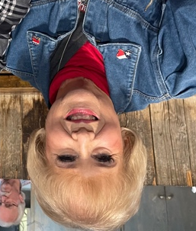
TEXAS SPECIAL SESSION UPDATE

Governor Abbott called a special session that started on July 21st to complete in 30 days. Big plans to tackle and finalize items such as the improvement of natural disaster forecasting and recovery after the recent floods in SB 1, SB 13 incentivize water infrastructure projects, a priority in Texas with severe drought and water supply challenges. SB 2 would enhance flood emergency communications and warning systems.

A highly anticipated bill by Sen Bettencourt to eliminate the STARR test is SB 8. This was one of the ones all hoped would pass in regular session. At this midpoint of the special session, it remains uncertain whether there is sufficient time or consensus to permanently eliminate the test. Lawmakers have not filed any new legislation to change the test or even publicly discuss the issue. To many things to negotiate and settle with TEA commissioners in such a short time.

There is a total of 16 items that Lt Governor Dan Patrick released as his priorities for the Special Session that span emergency preparedness, tax relief, education reform, redistricting and a host of social policy issues.
But SB 4 by Senator Phil King addressing redistricting threw a huge stop to everything else. The redistricting committee released the proposed redo of the map last Wednesday, July 30th. It slices up districts in the Houston, Austin and Dallas areas yielding five additional districts that are heavily Republican. As excepted the Democrats are not having it and fled the state over the weekend. Most of the 62 Democrats left on Sunday August 3^{rd,} which deprives the Republicans of a quorum of 100 members present to vote. The departed Democrats left for Chicago, New York and Boston which are in areas with Democrat Governors.

Governor Abbott will continue to call lawmakers back for subsequent sessions if they do not get a quorum. So, we will see what happens next. On Sunday August 3rd, the majority of Democrat elected officials fled the state and have not returned as of August 14th. No quorum has been achieved since the democrats fled.
Calendar of Events

Aug. 21st Luncheon
Sept. 1st Labor Day
Sept. 8th Board Meeting * 3801 Dixie * 11:30-1:00 pm
Sept. 13th ECRP Pancake Breakfast
Sept. 17th Constitution Day
Sept. 18th General Luncheon * MCM Elegante 11:30-1:00 pm
Sept. 25th NFRW Convention
Oct. 6th Board Meeting * 3801 Dixie * 11:30-1:00 pm
Oct. 16th General Luncheon * MCM Elegante 11:30-1:00 pm
Oct. 23rd TFRW Convention * San Antonio
Oct. 31st Halloween
Nov. 3rd Board Meeting * 3801 Dixie * 11:30-1:00 pm
Nov. 4th Election Day
Nov. 20th Last Luncheon of the Year! MCM Elegante

Political-Campaign Activities Chairman Kathy Wise
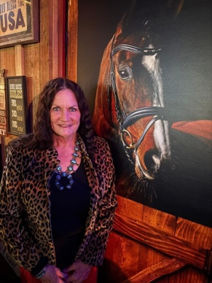

Campaign Activities (aka volunteer hours)

I have ‘bugged’ some of you for hours… volunteer hours. I should share why it’s important to our club instead of continually asking for your hours. (Which I will still do.)

Individual hours are collected from members. Hours, based on attendance, during our luncheons, patron events, and board meetings. These hours are added together. This number is used for the quarterly report I complete for TFRW. In the report I list the total hours from our club. Special recognition is given to the member with the most hours. I am amazed at how many hours volunteers put in for Republicans! I have filled out this report twice. The first quarter our top hours by one person was over 800 hours! The second quarter over 500 hours! This is incredible. But our club has over 5,000 hours each quarter. That’s with only about 25-30 members giving me their hours. Just think what we could have with all 200+ members of ECRW reporting. You can report hours based on watching the Presidential speech, attending election forums, registering people to vote, working at Republican Headquarters, attending fundraisers or meetings at Republican Headquarters.

Why are hours important?

Tracking/reporting hours for TFRW measures the influence of Republican Women in Texas. Time spent promoting/supporting the Republican Party shows our interest in politics in our area. Elected officials know which areas of our state have active clubs. We are among the most active. We must keep Texas RED.

Also, ECRW can win awards. Who does not want to win awards?

I don’t like ‘What if’ questions
But what if the 100 plus members who don’t report their hours did? What if it was only 5 hours a month? What if it was 15 hours a quarter?

So don’t think your “few” hours are not important, they are! Please send me your hours, either monthly or quarterly. There are no “hour” police. If you are unsure about what counts, please ask me. Call 423-634-6302 or email yellownags@aol.com.

Vice President Membership Heather Grimes

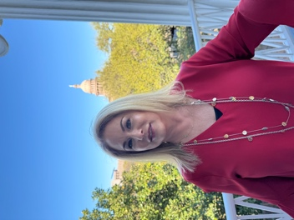
Membership continues to grow. We are currently at 241 members! Remember that we continue renewing and signing up members for 2025 until the end of October. It’s never too late to renew.

We are heading into a VERY critical election year and now is when we increase our members and educate them on the issues and the candidates. I know it’s a hard year to get members to renew, especially as we are more than halfway through the year. Many are sitting back and enjoying the fact that we are the majority statewide and nationwide. But without all of us active and involved, we may not hold these majorities. Complacency is our own worst enemy. Don’t forget to keep reaching out to potential new members. We have welcomed over 240 members this year, but I bet you may have friends or associates who would make great members.
I’m reading about so many fun activities being held by other clubs to reach out to new members. Please share your ideas for a fun fall membership drive activity with me at ecrwtexas@gmail.com.

Our next deadline for submitting memberships to TFRW will be August 25th for a final count towards the TFRW Convention. The number of members submitted by this deadline will qualify for club Delegate strength and determine member eligibility for the TFRW Convention in October. Only members in “good standing” can serve as Delegates and Alternates. Anyone who is not a current ECRW member, but who is considering attending the TFRW Convention must register / renew her membership prior to August 20, 2025 to ensure we meet the August 25th filing deadline.

Enjoy the rest of your summer and get ready for a fabulous Fall full of meetings with great speakers and celebrating being a Republican woman!

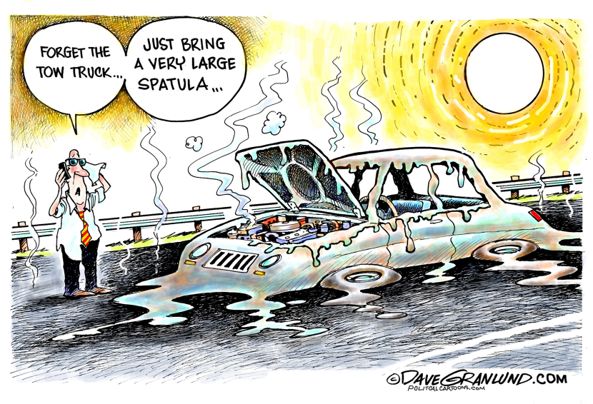

Newsletter Donna Kelm



Hello everyone. I hope you’ve had a fabulous summer and gained lots of memories!

As we move into the final months of 2025, I reminisce of a year ago being President of ECRW and being elected as ECRP Chair. It was a lot of work doing both, but I am so thrilled for the experience and challenge. Challenges are one of my passions. Since being Past President, I have continued to do the newsletter, website and keeping everyone abreast of what has been happening in our club with emails and texts messages. But my time as the ECRP Chair will start getting busier in September, so I am stepping down as Newsletter Editor. I hope everyone has enjoyed reading the newsletter as much as I have enjoyed presenting it. I have been accused of publishing a book at times…..sorry. My main goal was to keep everyone informed, educated on what was happening locally, statewide and nationally. I have really enjoyed going through all the pictures people share to place in the newsletter. So, thank you to everyone for sharing your articles, pictures, captions, etc. When Rachel became President almost 5 years ago, that’s when I decided to challenge myself to the task. I’ve loved it! So, thank you! I will continue to work on the website and sending texts and messages.

Important: If you are interested in submitting information to be placed in our ECRW newsletter, please email to: ecrwtexas@gmail.com. ECRW allows all Republican Candidates to place articles as well. ECRW Club does not support one Republican over another. Information contained in our Newsletter is for informational purposes only.

The ECRW Club Newsletter is an official publication and is emailed to its members. It contains information about the club, its members and important announcements and information regarding the political arena. If you would like to advertise, please contact us at the email listed above. Ector County Republican Women is a tax-exempt organization under Section 527 of the Internal Revenue Code. Contributions to ECRW PAC are not tax deductible as charitable for Federal Income Tax purposes. Corporate contributions are not permitted.



ECRW Newsletters ARE Available Online. Would you like to read a past edition of the ECRW Newsletter? If you missed out on an issue or are a new member and would like to read about what we’ve done in the past, all of the newsletters from 2021-present are available for you to download on our website! www.ecrwodessa.com

Awards Brenda Norman


Your Ector County Republican Women’s (ECRW) Board is always working behind the scenes to assure that your organization runs smoothly. One area that is important is Campaign Activities. This chairman compilates the hours members have worked promoting the Republication Party. The importance of this report shows in a quantitative figure the efforts we expend as a club. It is estimated that every hour worked by a member has a monetary value of thirty dollars to the Republican Party. This report is contingent on several factors. First, we must work the hours. Second, we must keep track of the hours (just an estimate, no one is going to make you prove your hours). And third, we must turn in those hours to the Activity Chairman. This year’s chairman is Kathy Wise. You can text (432.634.6302) or email (yellownags@aol.com) her your hours on a monthly or quarterly basis, as she is required to turn in her report to Texas Federated Republican Women (TFRW) quarterly. This report is especially important as it shows the impact ECRW has on a local, state, and national platform.
TFRW and NFRW (National Federated Republican Women) offer a number of awards. Donna Kelm, our newsletter editor, has submitted several our 2024 and 2025 newsletters in the Best Newsletter category. Donna has worked diligently to provide our members with current information on our club’s activities and other information of concern. You can access current and past editions of the newsletter on our website, www.ecrwodessa.com.

Another category of awards is the NFRW Achievement Award and the TFRW John Tower Award. As your 2025 Awards Chairman, this is my responsibility. As I recall, when Debi Hays – 2025 ECRW President, asked me to fill this position, she said it just required my reminding members when a report or action was due. I thought I could handle that. If she happened to mention that an awards application or two was required…I honestly don’t remember. If she did, I am sure I thought, “No problem, I can handle that.” Well, I should have looked at those applications before I committed to the position!
For one thing, the applications cover 2025 and 2024. I was out of the loop in 2024 due to my husband’s illness. Majority of these requirements are submitted to TFRW throughout the year, but they do not keep them available for this award. Judy Calloway helped me dig out the requirements of 2024 and even part of 2025. Thank you, Judy! I also had to rely on Heather Grimes, 2024 ECRW Treasurer, Donna Kelm, 2024 ECRW President, and Debi Hays, 2025 President to verify and provide required information, dates, and amounts. TFRW and NFRW are not as trusting in these awards as they are in our activity hours. No estimating or guessing here!

The NFRW Achievement Award had a possible 366 points available. A club our size had to accumulate 240 award points to qualify for the Diamond Award, the highest award possible. ECRW achieved 260 points!
I thought I had it made when I completed the NFRW award. After all, surely the TRFW award would be easier. Wrong! The NFRW award offered 366 points; the TFRW offered 1160 points. And they wanted specific data backup, as in exact amounts of money we donated and to what and when; dates of activities and programs; speaker names and program titles with contents and dates; titles of books we donated and to which schools; who went to certain activities and when – I better stop there, as I am breaking out in a sweat just remembering it.

I will add that out of a possible 1160 points; our size club required 750 points to qualify for the Diamond Award. ECRW racked up (and yes, we can prove it) 995 points! As a club, you can be proud of your achievement. These awards represent not just the officers nor the board. They represent the members of the club who give their time, energy, talent, and other assets to further the cause of the Republican Party. What You do is important. We need to celebrate that.

Governor Abbott travels to West Texas
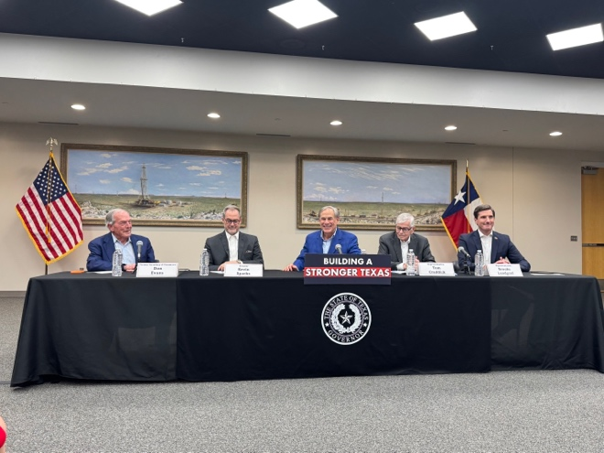
June 5th - Governor Abbott came to West Texas to sign into law key legislation to protect Texas’ oil and gas industry and promote economic growth across West Texas, including SB494, SB 529, SB 1806, HB 48 and the Beacon Budget Appropriation during a bill signing ceremony at the Permian Basin Petroleum Museum.
“Today is a defining moment for the Permian Basin, the future of this region, and the future of Texas,” said Governor Abbott. “We are bringing the full weight of the law to crack down on oil theft in the Permian Basin to protect the critical role energy development plays in fueling our economy. I’m also signing an item to fund an historic $123 million investment in The Beacon, a pivotal economic development project for Midland-Odessa.
gov.texas.gov

Former U.S. Secretary of Commerce Don Evans, Senator Kevin Sparks, Representative Tom Craddick and Representative Brooks Landgraf.

L: ECRP Chair Donna Kelm, Mayor Cal Hendrick, Judge Dustin Fawcett, Representative Brooks Landgraf.
R: Governor showing Bill. FR: Governor Abbott and Donna Kelm
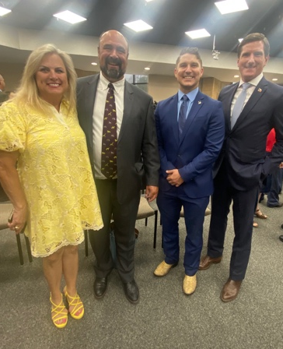
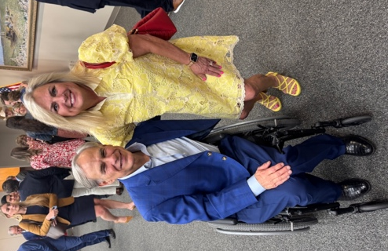
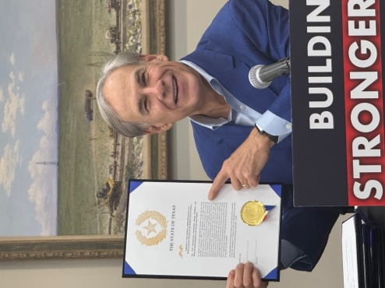
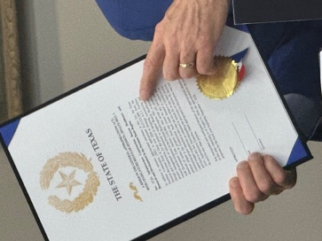
Governor Abbott comes to the Permian Basin.
Railroad Commissioner, Christi Craddick with Donna; Governor Abbott and Judge Fawcett; Signed Bill; Senator Sparks, Governor Abbott, Representative Craddick and Representative Landgraf.
Texas Railroad Commissioner, Christi Craddick with Donna; Governor Abbott with Judge Fawcett, Signed Bill, Rep. Landgraf and Rep. Craddick with Governor Abbott and Senator Sparks.
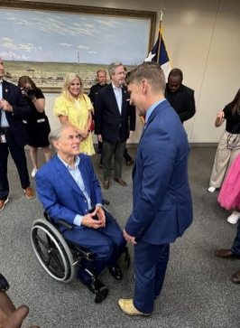
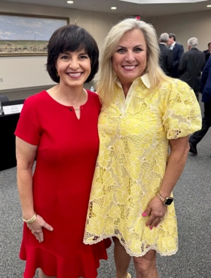
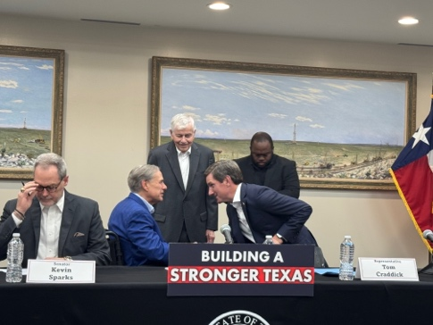

Patron Event Planner Rachel Minor

Ready to mix the hard work of politics with a little fun?

Become an ECRW Patron and join us for a year full of exciting, themed events that’ll have you laughing, connecting, and building friendships that last a lifetime! For just $100, you’ll be invited to exclusive gatherings that make the work of politics feel like a party.

So far, Patrons have enjoyed one-of-a-kind gatherings, thanks to the generosity and warm hospitality of friends like Cal & Amy Hendrick, who opened their gorgeous home for our “Wild” About ECRW kickoff (and wow — the food was incredible!), then Bill Nyborg, whose Freedom & Floaties pool party was the perfect blend of sunshine, laughter, and great conversation.

But we're not done yet! There are two more fun-filled events on the horizon to round out this incredible year. If you want to work hard and play hard, ECRW Patron membership is the way to go. Come for the politics, stay for the fun — you won’t regret it!

Join us as an ECRW Patron for just $100 — fight for conservative values, connect with like-minded friends, and enjoy exclusive themed events all year long.

For just $100, you’ll be part of exclusive events that bring together passionate people in the most fun, relaxed settings.

Watch for two more fabulous events coming up before the year ends and trust us — you’ll want a seat at the table (or a float in the pool). Come for the cause, stay for the camaraderie… and let’s make more memories together!

Become an ECRW Patron and join us for a year full of exciting, themed events that’ll have you laughing, connecting, and building friendships that last!

We the People of the United States, in Order to form a more perfect Union, establish Justice, insure domestic Tranquility, provide for the common defense, promote the general Welfare, and secure the Blessings of Liberty to ourselves and our Posterity, do ordain and establish this Constitution for the United States of America.
— Preamble to the Constitution of the United States
In 2004, Congress passed legislation establishing Constitution and Citizenship Day, a federal holiday commemorating the ratification of the U.S. Constitution on Sept. 17, 1787.

Wild About ECRW Patron Event
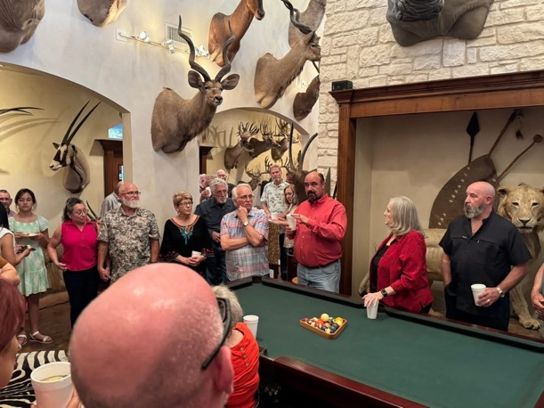
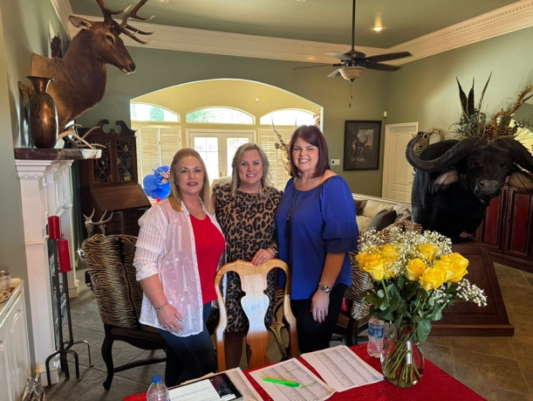
Thank you, Amy and Mayor Cal Hendrick


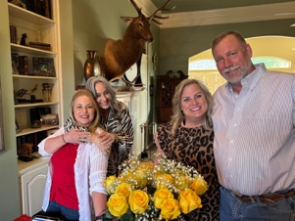


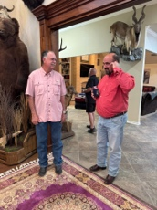
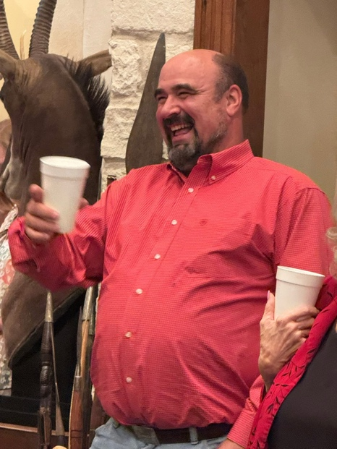
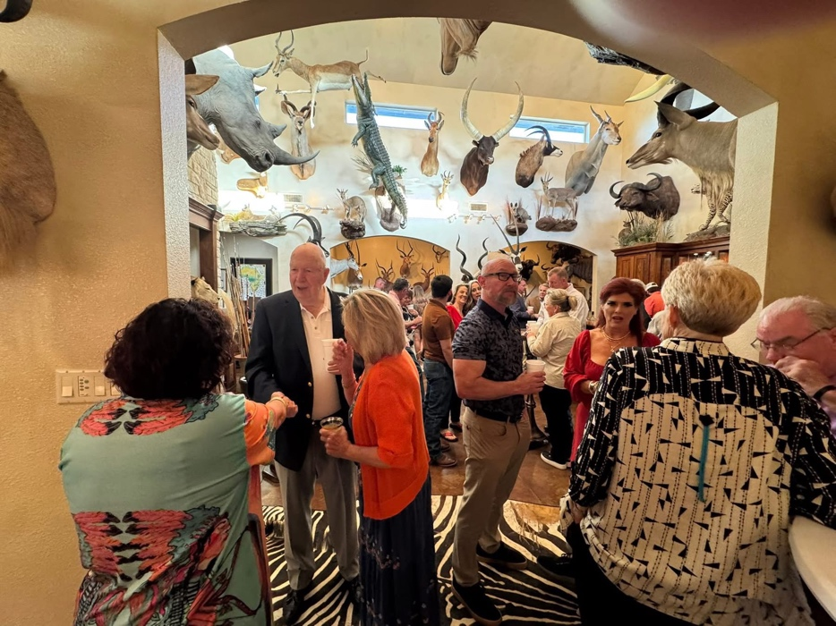
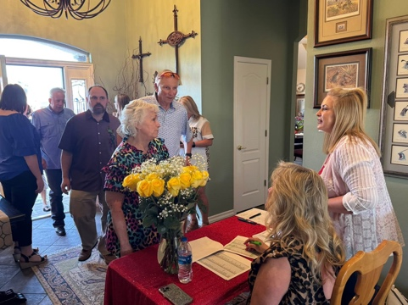


Freedom & Floaties Patron Event
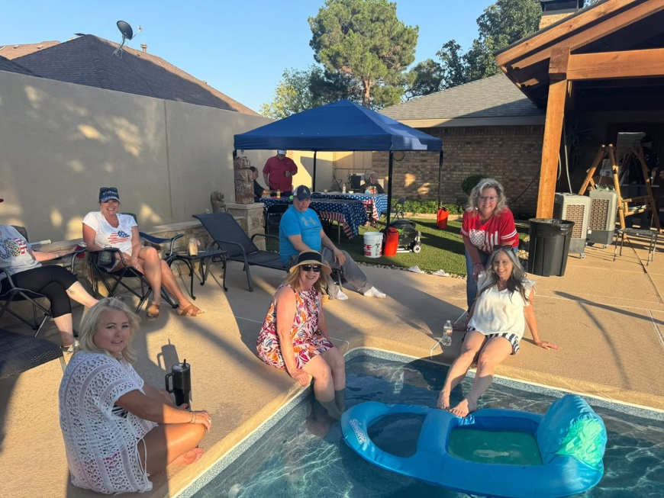
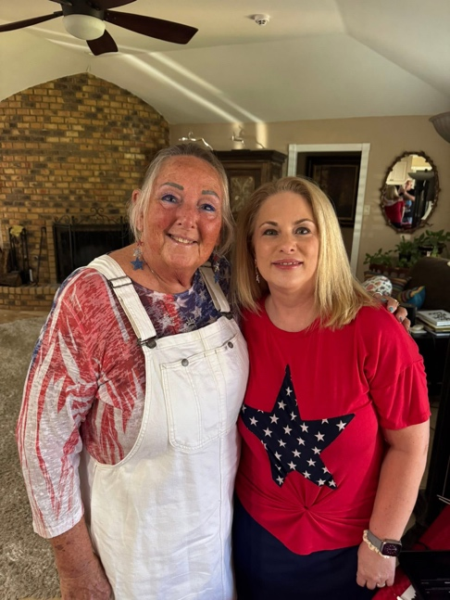


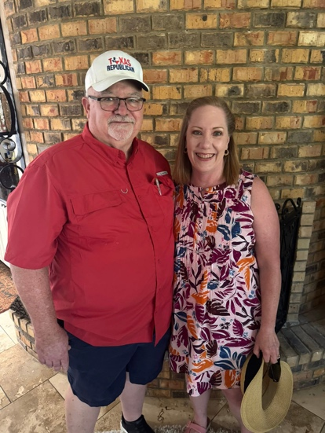


Thank you, Bill Nyborg!

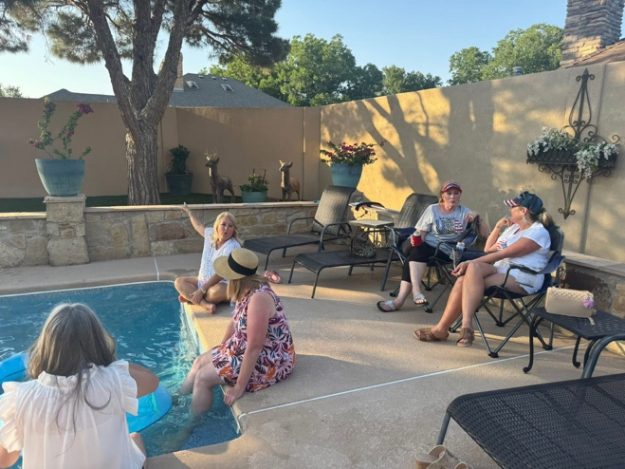
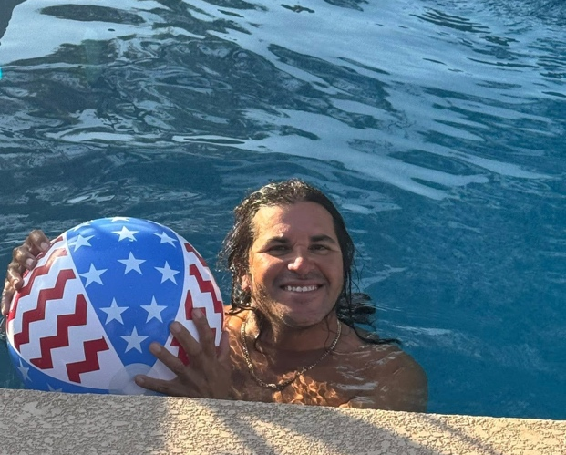




.CONVENTION REGISTRATION
Regular Registration $250.00 – August 1 thru September 30

Late Registration $325.00 – October 1 thru October 10th
HOTEL RESERVATIONS ARE NOW AVAILABLE
Grand Hyatt 600 E Market Street, San Antonio, Texas



National Federation
Republican Women
NFRW 43rd BIENNIAL CONVENTION
Rosen Shingle Creek, Orlando, Florida
September 25-28, 2025

Watch for the notice in the Capitol Connection for the Registration ($300) which will be available till August 24th. One Delegate and one Alternate is allotted for each Club. Any member may attend as a guest. Cost after Early Bird Special is $495. -


IMPORTANT ELECTION DATES
Oct 6 Last day to Register to Vote
Oct 20 First day of Early Voting in person
Oct 24 Last day to Apply for a Ballot by Mail
(RECEIVED, not postmarked)
Oct 31 Last day of Early Voting in person
November 4, 2025 Constitutional Election



Important 2026 Election Dates
**These dates are subject to changes from the 2025 legislative session**
Longer calendars are on the Conducting Your Elections pages when available.
Tuesday, March 3, 2026 - Primary Election
First day to file for a place on the Primary ballot for precinct chair candidates. | Tuesday, September 9, 2025
First day to file for all other candidates for offices that are regularly scheduled to be on the Primary ballot; first day for independent candidates to file declaration of intent. | Saturday, November 8, 2025
Filing deadline for primary candidates; filing deadline for independent candidates to file declaration of intent. | Monday, December 8, 2025 at 6:00 PM
First day to apply for a ballot by mail using Application for a Ballot by Mail (ABBM) or Federal Postcard Application (FPCA). | Thursday, January 1, 2026*  *First day to file does not move because of New Year’s Day holiday. An “Annual ABBM” or FPCA for a January or February 2026 election may be filed earlier, but not earlier than the 60th day before the date of the January or February election.
Last Day to Register to Vote | Monday, February 2, 2026
First Day of Early Voting | Tuesday, February 17, 2026*  *First business day after President's Day
Last Day to Apply for Ballot by Mail (Received, not Postmarked) | Friday, February 20, 2026
Last Day of Early Voting | Friday, February 27, 2026
Last day to Receive Ballot by Mail | Tuesday, March 3, 2026 (Election Day) at 7:00 p.m. if carrier envelope is not postmarked, OR Wednesday, March 4, 2026 (next business day after Election Day) at 5:00 p.m. if carrier envelope is postmarked by 7:00 p.m. at the location of the election on Election Day (unless overseas or military voter deadlines apply)⁴



Structure of Federation of Republican Women Judy Calloway

NATIONAL FEDERATION OF REPUBLICAN WOMEN aka NFRW

All 50 states plus District of Columbia and Puerto Rico that have Republican Women clubs are under the umbrella of NFRW as the parent organization. Founded in 1938, the National Organization consists of elected officers and a board of women representing the entire United States. NFRW has over 57,000 female members divided into 8 regions of the country. Each region elects a director; Texas is in region 4, led by Martha Jenkins, the incoming NFRW President for 2026-2027. Region 4 consists of 5 states Kansas, Louisiana, New Mexico, Oklahoma, and Texas with a total of 246 clubs and 13,565 members. More members than any other region and Texas has the most clubs and members in region 4.

TEXAS FEDERATION OF REPUBLICAN WOMEN aka TFRW

Each state is under the guidance and rules set by NFRW with a state organization in control of the clubs in that state, ours being TFRW in Austin. TFRW elects its officers and board members at a bi-annual State Convention. TFRW was established in 1955; ECRW became a club in 1960. Each of Texas's 31 senate districts is assigned a District Director who supervises its respective clubs. Currently the ECRW District Director is Judy Calloway of Odessa. Texas has 159 clubs with 9,680 members. TFRW oversees Texas clubs and addresses by-law violations.

ECTOR COUNTY REPUBLICAN WOMEN aka ECRW

Founded in 1960, ECRW is a third-tier club within the TFRW and NFRW structure. The Executive Board consists of President, Vice President of Membership, Vice-President of Programs, Treasurer, Secretary and Past President elected by the club members. The Board consists of members responsible for club operations, such as Legislative Action, Campaign Activities, Parliamentarian, and other support roles. The club President selects these individuals to be part of the working group. Our goal is to motivate, educate, and support women wanting to serve in our community as elected officials. The club functions in accordance with established by-laws and offers a range of opportunities for both learning and service. We uphold Christian values and support the Republican Platform. When you become a member of ECRW you are also a member of TFRW at state level and NFRW on national level.

Break down of your $40 membership Dues:
NFRW (National) $20
TFRW (State) $5.30
ECRW(Local) $14.70
Badges cost $10 leaving $4.70 to the club.

Constitution Day commemorates the formation and signing of the U.S. Constitution by thirty-nine brave men on September 17, 1787, recognizing all who are born in the U.S.
or by naturalization, have become citizens.

Ector County Elections coming up in the Primaries, March 3, 2026

Position Current Official
District Judge, 7oth Judicial Dist. Denn Whalen
District Judge, 244th Judicial Dist. Lori Ruiz-Crutcher
District Judge, 358th Judicial Dist. John Shrode
County Judge, Dustin Fawcett
Judge, County Court at Law Judge, Brooke Hendricks
Judge, County Court at Law 2, Christopher Clark
District Clerk Guadalupe Navarrette
County Clerk Jennifer Martin
Treasurer Cleopatra Anderson-Callaway
County Commissioner, PCT 2 Greg Simmons
County Commissioner, PCT 4 Billy Hall
Justice of the Peace, PCT 1 Carlos Chavez
Justice of the Peace, PCT 2 Missi Walden
Justice of the Peace, PCT 3 W.T. “Bill” Bowen
Justice of the Peace, PCT 4 Elizabeth R. Baeza
Precinct Chairs

County Chair Donna Kelm
This Photo by Unknown Author is licensed under CC BY-SA-NC

You are eligible to register to vote if:

You are eligible to register to vote if:
- You are a United States citizen;
- You are a resident of the county where you submit the application;
- You are at least 17 years and 10 months old on the date your voter registration application is submitted, and you are 18 years of age on Election Day.
- You are not a convicted felon (you may be eligible to vote if you have completed your sentence, probation, and parole); and
- You have not been declared by a court exercising probate jurisdiction to be either totally mentally incapacitated or partially mentally incapacitated without the right to vote.

Ballot Language for the November 4, 2025 Constitutional Amendment Election

"The constitutional amendment providing for the creation of the permanent technical institution infrastructure fund and the available workforce education fund to support the capital needs of educational programs offered by the Texas State Technical College System."
Proposition 2 - SJR 18
"The constitutional amendment prohibiting the imposition of a tax on the realized or unrealized capital gains of an individual, family, estate, or trust."
Proposition 3 - SJR 5
"The constitutional amendment requiring the denial of bail under certain circumstances to persons accused of certain offenses punishable as a felony."
Proposition 4 - HJR 7
"The constitutional amendment to dedicate a portion of the revenue derived from state sales and use taxes to the Texas water fund and to provide for the allocation and use of that revenue."
Proposition 5 - HJR 99
"The constitutional amendment authorizing the legislature to exempt from ad valorem taxation tangible personal property consisting of animal feed held by the owner of the property for sale at retail."
Proposition 6 - HJR 4
"The constitutional amendment prohibiting the legislature from enacting a law imposing an occupation tax on certain entities that enter into transactions conveying securities or imposing a tax on certain securities transactions."
Proposition 7 - HJR 133
"The constitutional amendment authorizing the legislature to provide for an exemption from ad valorem taxation of all or part of the market value of the residence homestead of the surviving spouse of a veteran who died as a result of a condition or disease that is presumed under federal law to have been service-connected."
Proposition 8 - HJR 2
"The constitutional amendment to prohibit the legislature from imposing death taxes applicable to a decedent's property or the transfer of an estate, inheritance, legacy, succession, or gift."
Proposition 9 - HJR 1
"The constitutional amendment to authorize the legislature to exempt from ad valorem taxation a portion of the market value of tangible personal property a person owns that is held or used for the production of income."

Page 2 of Ballot
Proposition 10 - SJR 84
"The constitutional amendment to authorize the legislature to provide for a temporary exemption from ad valorem taxation of the appraised value of an improvement to a residence homestead that is completely destroyed by a fire."
Proposition 11 - SJR 85
"The constitutional amendment authorizing the legislature to increase the amount of the exemption from ad valorem taxation by a school district of the market value of the residence homestead of a person who is elderly or disabled."
Proposition 12 - SJR 27
"The constitutional amendment regarding the membership of the State Commission on Judicial Conduct, the membership of the tribunal to review the commission's recommendations, and the authority of the commission, the tribunal, and the Texas Supreme Court to more effectively sanction judges and justices for judicial misconduct."
Proposition 13 - SJR 2
"The constitutional amendment to increase the amount of the exemption of residence homesteads from ad valorem taxation by a school district from $100,000 to $140,000."
Proposition 14 - SJR 3
"The constitutional amendment providing for the establishment of the Dementia Prevention and Research Institute of Texas, establishing the Dementia Prevention and Research Fund to provide money for research on and prevention and treatment of dementia, Alzheimer's disease, Parkinson's disease, and related disorders in this state, and transferring to that fund $3 billion from state general revenue."
Proposition 15 - SJR 34
"The constitutional amendment affirming that parents are the primary decision makers for their children."
Proposition 16 - SJR 37
"The constitutional amendment clarifying that a voter must be a United States citizen."
Proposition 17 - HJR 34
"The constitutional amendment to authorize the legislature to provide for an exemption from ad valorem taxation of the amount of the market value of real property located in a county that borders the United Mexican States that arises from the installation or construction on the property of border security infrastructure and related improvements."

What is a Precinct Chair? ECRP Chair, Donna Kelm

A precinct chair is an elected or appointed official who represents a specific geographic area (a precinct) within a political party. They act as a liaison between the party and the voters in their precinct, often serving as the party's point of contact at the grassroots level. Precinct Chairs are members of the County Executive Committee, elected at the Republican Primary election, who have a legal duty to participate in state-mandated and local County Party business.

How do I become a Precinct Chair?
Qualified candidates are elected every two years in the Republican Primary by voters in their precinct for a two-year term. The next primary election is in 2026. If interested, contact the County Chair, Donna Kelm to discuss being appointed to fill a Precinct Chair vacancy. The Party Chair may appoint qualified individuals to fill any vacant precinct chair positions, subject to an affirmative majority vote by the current precinct chairs. The appointed Precinct Chair immediately assumes the duties and responsibilities of the position but may not vote on official Party business until their appointment is ratified at the next official meeting of the County Executive Committee. All precinct chair candidates must complete an Application for a Place on the General Primary Ballot for a Precinct or County Chair, have it notarized, and present it to the County Chair in order to run in the Republican Primary. Notarization is available by the County Chair.

Democrats Walk Out on Texas. Representative Brooks Landgraf

It’s also worth noting that this quorum break is nothing more than a publicity stunt. This is the fourth quorum break in recent Texas history. Not one of them has worked. Eventually, the missing members come back, and the legislation they tried to block ends up passing anyway. But they do get their brief moment to fundraise and have their faces on national television.
If these members were truly serious about opposing the redistricting plan, they’d come to the Capitol, make their case, and vote no. Every session, there are bills I don’t agree with. That doesn’t mean I abandon my responsibilities or violate my oath. I know that the fight remains in the Capitol, not thousands of miles away.
The House will attempt to reconvene again on Friday, with the expectation that enough Democrats will return for us to resume the people’s business. By the time you read this, we’ll know whether that happened. But special sessions only last 30 days, and thanks to this walkout, we’ve already lost a critical week to act on important legislation.
Regardless of what others do, whenever the Texas House of Representatives is in session to do the work of the people of Texas, I will be at my post. That’s what 200,000 West Texans elected me to do.
God bless Texas, Brooks Landgraf

Texas State Capitol
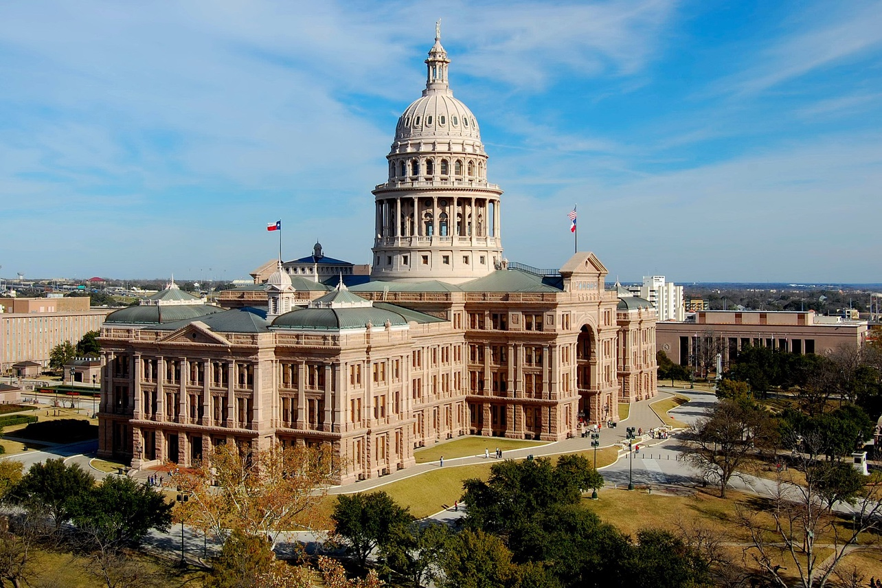

At the time of its construction, the capitol was billed as "The Seventh Largest Building in the World".

Woman of Distinction, August 2025 TFRW Newsletter


Debi Hays is a leader whose career bridges public service, business, and community engagement.

Debi served as the Ector County Judge from 2018 - 2022. After winning the Republican primary with a commanding 63% of the vote, she was appointed to the position in June 2018 to succeed the prior Judge. Debi brought visionary leadership to local government championing initiatives that improved infrastructure, public safety, environmental enforcement, and promoted ways to cut government spending. Her tenure was marked by bold decisions, including spearheading the Ector County Assistance District to generate $30 million in additional revenue to minimize the tax burden on the taxpayers.

Her leadership extended beyond county lines when Debi was selected to chair the Permian Basin Regional Freight Plan Advisory Committee, a 22-county effort to enhance transportation, safety, and mobility across west Texas. Governor Abbott appointed Debi to serve on the Commission of State Emergency Communications from 2018-2022. She also served as SREC SD31 2018-2021 and Ector County GOP Precinct Chair 2014-2019.

Her impact goes far beyond politics. Debi is a passionate champion for women’s empowerment, dedicating time and energy to mentoring, organizing, and inspiring women to lead with confidence. Her work with TFRW further amplifies her commitment to elevating women’s voices in public service. Debi served as Ector County Republican Women President 2015-2017 and is the current President. She has served on TFRW standing committees as Campaign Victory and Texas Association of Counties Liaison, and currently serves as Deputy President, Region IX.


Her community service includes Board roles with organizations such as Crime Stoppers, American Heart, Alzheimer’s and Cancer Association, and the Permian Playhouse. Married to her husband Dwayne for 46 years, Debi’s life reflects a deep commitment to service, leadership, and lifting others up wherever she goes.

TFRW Today | AUGUST 2025 -30- TEXAS FEDERATION OF REPUBLICAN WOMEN

